1. Difference the function and class component
2. class component life cycle
3. Regarding git operation
4. difference between hash routing and browser routing
5. Promise
6. callback
7. HOC
8. closure
9. Redux flow
10. difference shallow and deep comparison
11. props from parent to child and child to parent
12. formik and yup validation
13. CSS precessor
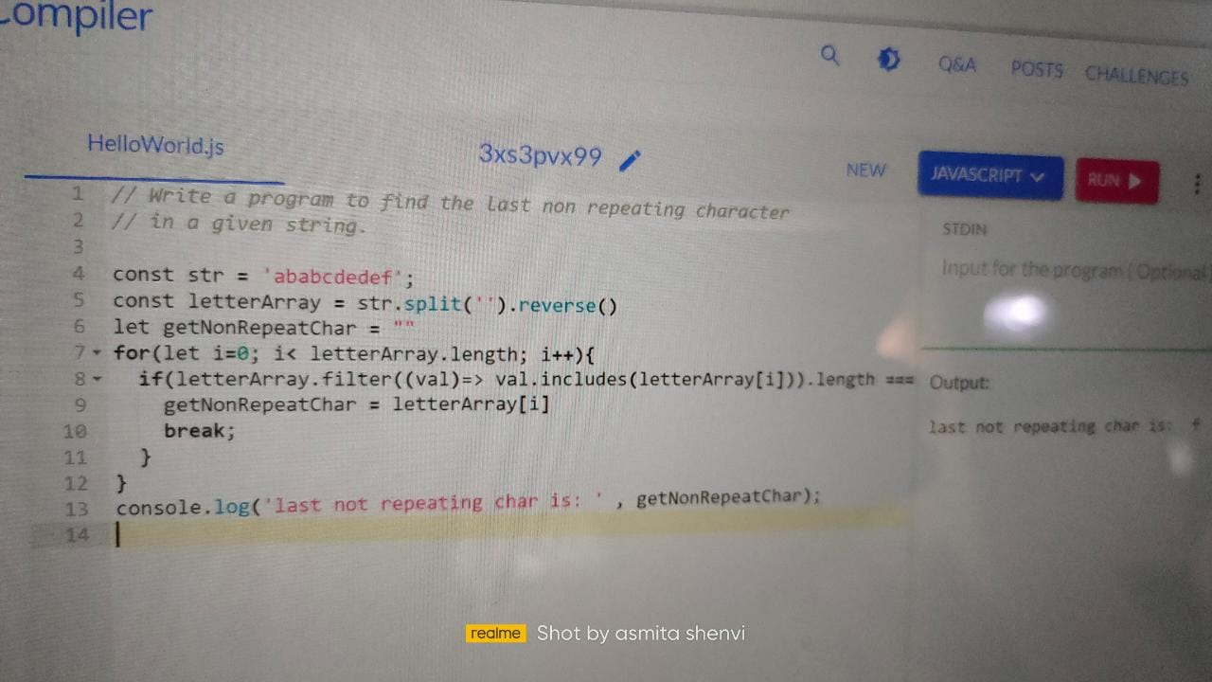

Set2:

1. About project
2. Which react hooks you have used in your project
3. Difference between usememo and usecallback
4. What feature you have implemented in your project
5. What is the use of useEffect
6. Attributes used along with display flex
7. What are promises
8. What Async returns
9. Difference between display position absolute and relative
10. Can you manage css on your own
11. What is the use of await function

Set3:

These are the question that I encountered in the Mobisoft interview questions:
Why do we use hooks?
What are the hooks used in project...?
Explain about the project...?
What was the feature that you recently implemented in the project...?
Difference between useCallback and useMemo...?
Alternative to componentDidMount in functional components and why we use it..?
Attributes used along with display: flex...?
CSS preprocessors used in project...?
Why use React instead of other frameworks, like Angular?
What was challenging in the project...?

